1. Create tree view like the following:  
   -When the mouse goes over an item the sub list should be shown  
   -The tree view should work with unlimited number of sub lists  
   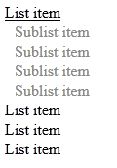
2. Create the following Web page using external CSS styles. Buttons should consist of PNG images with text over them.  
   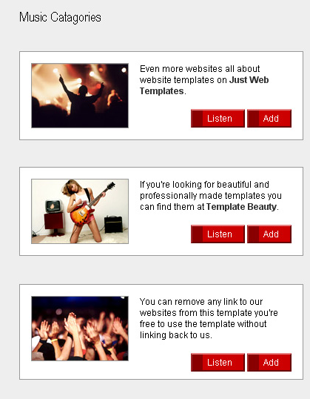
3. Create the following Web page using HTML with external CSS file. Note that the images should be PNG with transparent background.  
   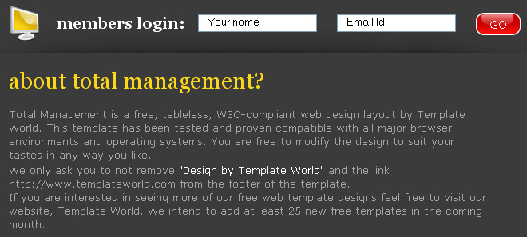
4. Given the picture below create the Web site  
   -Use CSS and HTML 5  
   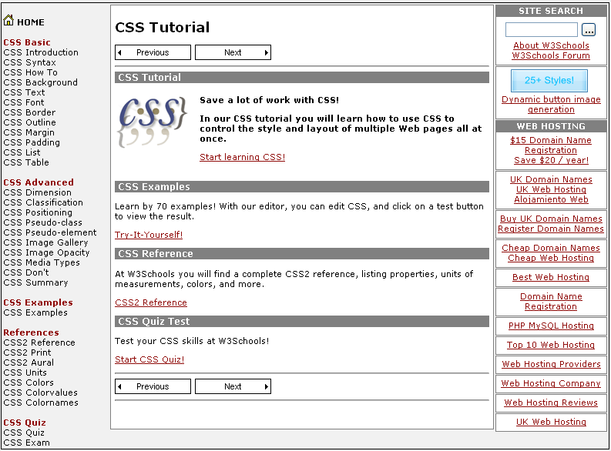
5. Create the following HTML 5 Page  
   -Do it without tables  
   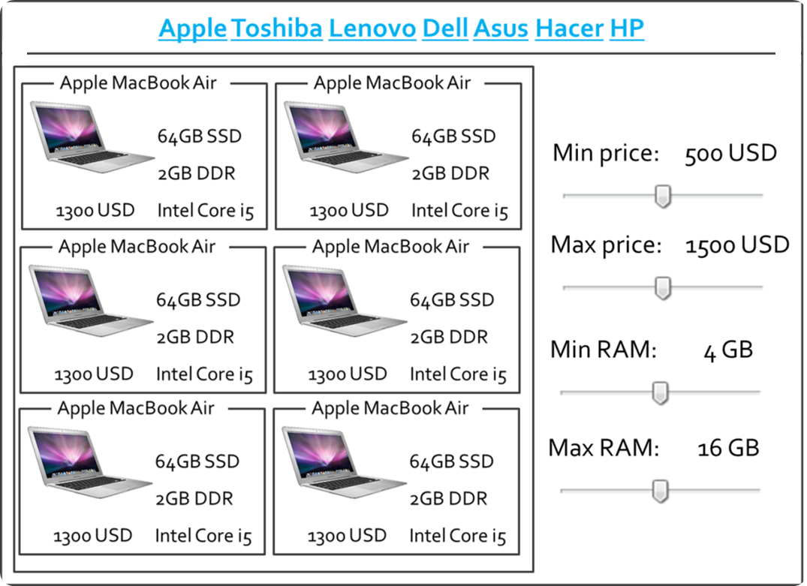
6. Create the following Web page using HTML and external CSS. Using tables, inline styles and deprecated tags is not allowed.

